Library self guided tour instructions

- Download the GooseChase Android or iPhone app.

- Choose to play as a guest; or register for a personal account with an email, username, and password of your choice.
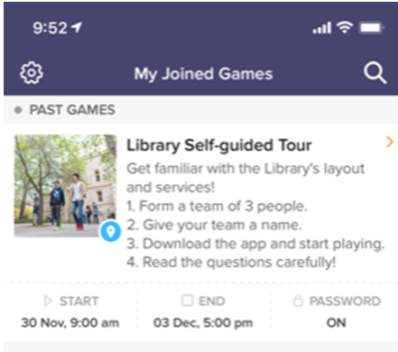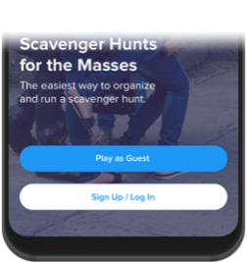

- Tap the search icon and enter the game code (4XDK4K).
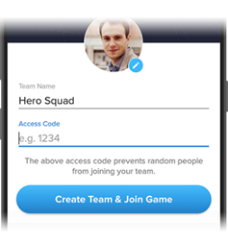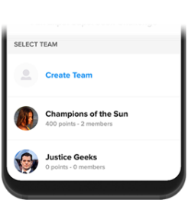

- Once in the game, you’ll be presented with the missions you are attempting to complete. Mission types can include photo/video, text or GPS check in. To complete a mission, select it from the list and hit the “Snap Evidence” button.

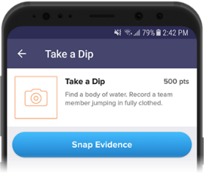

- Make sure you’re completing missions accurately! (e.g. “take a picture of the comfy chair” means take a picture with a real chair, not a chair on a computer screen)

- Using the navigation tabs, you can keep track of how you are doing via the activity feed and the leaderboard, see notifications from the game organizer or review (and resubmit) your previous submissions.
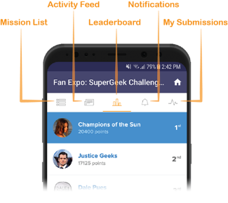

- Most importantly, have fun getting to know the Barr Smith Library! Get really creative.

