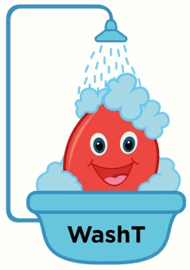
The WashT Trial
Does washing blood for transfusion make a difference to preterm babies?

Transfusion with washed versus unwashed red blood cells to reduce morbidity and mortality in infants born less than 28 weeks gestation: a multi-centre, blinded, parallel group randomised controlled trial. The WashT Trial

Investigators
A/Prof Michael Stark, Dr Chad Andersen (Department of Neonatal Medicine, Women’s and Children’s Hospital); A/Prof Carmel Collins, Dr Thomas Sullivan (South Australian Health and Medical Research Institute); Dr Denese Marks (Australian Red Cross Lifeblood); A/Prof Rachael Morton (NHMRC Clinical Trials Centre, University of Sydney); Dr Louise Owen (The Women’s Hospital & University of Melbourne)

Preterm babies often receive a blood transfusion (where blood is given because the blood count falls) during their stay in the nursery. While transfusions save lives in the NICU setting the potential for RBC transfusion related adverse outcomes is an area of growing interest and concern. In sick adults and children, research suggests transfusion with washed blood may reduce illness.

This study will determine the potential for transfusion with washed RBCs to reduce the incidence of transfusion associated neonatal mortality and increase survival free of significant neonatal morbidity compared to current standard transfusion practice.

The blood used for transfusion is extensively screened by the Australian Red Cross Lifeblood Service and is very safe. Both washed and unwashed blood are held by all transfusion laboratories. Both are licenced for use and can be specifically requested at the doctor’s choice.

What is the purpose of this project?
The aim of this project to work out if washing blood for transfusion makes a difference in preterm babies. The study will investigate how the washed blood affects problems related to preterm birth.

Who is participating?
Neonatal nurseries across Australia are participating in WashT. All babies born less than 28 weeks are included in this project if the nursery staff caring for your baby decide a red blood cell transfusion is needed. Babies will have a 50/50 chance of receiving either unwashed blood or an identical pack of washed blood from the Red Cross.

Partnership with the Australian Red Cross is central to this proposal, providing expertise in blood product development. If this trial results in both short- and longer-term benefits for preterm babies this support will also allow rapid research translation and adoption into routine neonatal clinical practice,

ANZCTR registration: ACTRN12620000530921

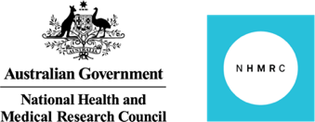
Funding Research Partners
