Appendix C

HAZARD MANAGEMENT – SAFE OPERATING PROCEDURE (SOP)

Only to be completed where required as a control measure under a Risk Assessment

A document setting out the requirements to carry out the work in a safe and healthy manner and in a logical sequence.  It must be able to be easily read by those who need to know what has been planned.  It is relevant to the following people:  - the worker carrying out the work; and  - the person who has management and control over the work. | A SOP, if identified as a control measure, is to:  - identify the work;  - specify/address the identified hazards relating to the work;  - describe the measures to be implemented to control the risks;  - take into account the circumstances at the workplace that may affect the way in which the work is carried out;  - take into account emergency management arrangements where applicable; and  - be communicated to all workers who carry out the work.

NAME OF THE TASK/ACTIVITY |  |  | date:
LOCATION |  |  | Insert photo  (Optional)
Risk assessment (RA) NaMe
Residual risk rating on the RA |  | ☐ Low ☐ Medium ☐ High ☐ Very High
Hazards identified on the RA

PERSONAL PROTECTIVE EQUIPMENT (be specific AND specify ppe TO BE WORN during the task)
(delete the ROW IF NOT APPLICABLE)
 | Eye protection: ☐ Safety glasses ☐ Eye shields ☐ Safety goggles  ☐ Other:
 | Face protection: ☐ Dust goggles ☐ Face shield ☐ Visor ☐ Face mask ☐ Dust mask  ☐ Other:
 | Respiratory protection: ☐ Half face mask ☐ Air-purifying respirator ☐ Supplied air respirator  ☐ Other: |  | 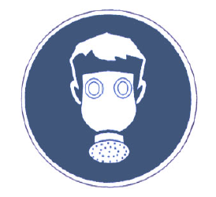 | ☐ Full face mask
 | ☐ Long hair must be contained or covered  ☐ Other:
 | Head protection: ☐ Hard hat  ☐ Other:
 | Hand protection: ☐ Rubber ☐ Cut resistant ☐ Leather ☐ Vinyl ☐ Neoprene ☐ Nitrile ☐ Barrier creams  ☐ Other:
 | ☐ Enclosed footwear: ☐ Footwear that is resistant to spills of hazardous substances ☐ Boots with steel caps  ☐ Other:
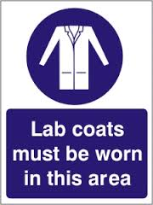 | Protective clothing: ☐ Lab coat ☐ Gown ☐ Long sleeves ☐ Long pants ☐ High visibility ☐ Helmet ☐ Sun protection  ☐ Other:
 | Hearing protection ☐ Ear plugs ☐ Ear muffs  ☐ Other:
DESCRIBE, in sequence, steps TO complete the activity safely
Pre-operational checks

Operational checks/steps to complete the activity from start to finish (including transport and waste disposal where relevant)

On completion of work – steps to make safe (including clean up, any waste disposal & service/maintenance requirements)

Emergency and Spill Procedures, Transport or storage requirements (where relevant), First aid/Medical

Prepared by
People involved in the drafting of
this SOP
Person authorising the SOP | Name: |  | Signature
 | Position:
This SOP must be reviewed after any incident/injury associated with this activity or when a Risk assessment is reviewed.
File your completed SOP as instructed by the Supervisor/Person in control of the area/activity and retain the SOP in accordance with the State
Records of SA, General disposal Schedule No. 30 issued under the State Records Act 1997. (Contact the University’s Records Management Office
for further assistance/information if required.)

