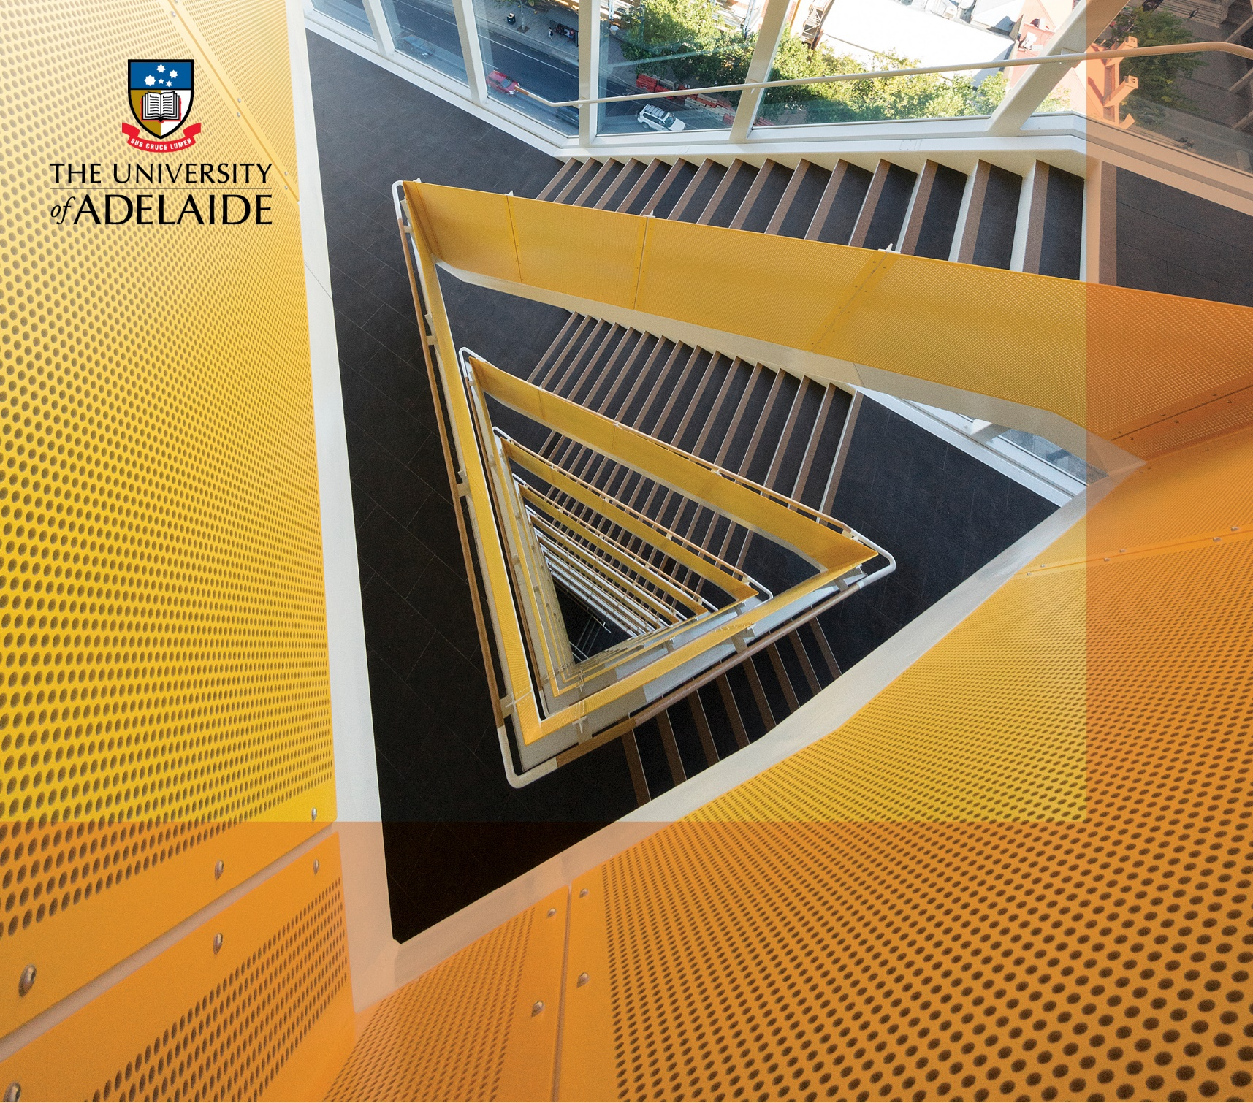

DESIGN STANDARD

O. Sustainability Metrics

Contents

Revision log 3

1. Abbreviations 4

2. Introduction 4

3. Technical Requirements 4

3.1 General Documentation Requirements 4

3.1.1 Purpose of Documentation 4

3.1.2 Scope and Time Delivery of Documentation (Sustainability Metrics) 4

3.2 Glossary of Terms 5

4. Sustainability Metrics Requirements 5

4.1 Lighting 6

4.2 Space Heating, Cooling and Ventilation 6

4.3 Process Heating and Cooling 6

4.4 Building Envelope 7

4.5 Electrical (Equipment and Appliances) - Hardwired 7

4.6 On-site Renewable and Alternative Energy Initiatives 7

4.7 Water Management 8

# Revision log

## Current issue

O. Sustainability Metrics - UoA Design Standards. Version 1.1 March 2025

## Previous issues

|  |  |  |  |  |
| --- | --- | --- | --- | --- |
| Version | Authors | Description/ updates | Revision | Date |
| 1.0 | Vikram Kenjie and Dammika Weerakkody, UoA | O. Sustainability Metrics - UoA Design Standards | Version 1 | December 2024 |
| 1.1 | Dammika Weerakkody, UoA | O. Sustainability Metrics - UoA Design Standards | Version 1.1 | March 2025 |

## List of revised items

|  |  |  |  |
| --- | --- | --- | --- |
| Version | Authors | Revised items | Date |
| 1.1 | Dammika Weerakkody, UoA | Item 3.1 -General Documentation Requirements. | March 2025 |

## Revision management

It is anticipated that revisions to this document will be undertaken regularly to address practical situations and respond to changes in sustainability standards.

## Endorsement body

Director of Infrastructure

## Owner

Director, Capital Projects & Facilities Management

## Contact person

Director, Capital Projects & Facilities Management

## Authors and acknowledgements

The standard has been developed by Infrastructure Branch of UoA.

1. Abbreviations

(refer –Standard Volume A. Project Process Checklist)

1. Introduction

(refer –Standard Volume A. Project Process Checklist)

1. Technical Requirements

(refer –Standard Volume A. Project Process Checklist)

This volume must be read in conjunction with Vol. A Project Process Checklist. Particular attention must be given to obligations relating to:

* Communication with, and distribution of documentation to UoA stakeholders.
* Documentation and certification obligations at milestone checkpoints throughout the project.

Also, this volume must be read in conjunction with various volume of Design Standards eg Volume B to M for detailed design requirements.

* 1. General Documentation Requirements

The Sustainability Metrics Calculations Spreadsheet (refer section 4. Sustainability Metrics Requirements) must be provided by the consultant at Post Construction, however the metrics data needs to be collected during the various phases of the project. Refer Volume A checklist.

* + 1. Purpose of Documentation

The University’s Sustainability Strategy 2030 – Here for Good outlines the institution’s strategic plan to address the accelerating environmental, social, economic, and human-induced climate changes occurring globally.

Under the “Here for Good” commitment, the University is working towards Net Zero operational targets, with campus refurbishment and building upgrade projects playing a vital role in this initiative.

Going forward, every Infrastructure capital project must include separately estimated improvements to various relevant sustainability metrics such as energy & associated cost savings, electricity network demand savings, carbon emission abatement, water efficiency improvement, reduced waste to landfill etc.

New reporting templates are now specified here when undertaking in the University’s updated UoA Design Standards. This document should be read in conjunction with the other UoA Design Standards volumes.

* + 1. Scope and Time Delivery of Documentation (Sustainability Metrics)

Sustainability Metrics related data needs to be gathered as per the description on the Sustainability Metrics – Calculations spreadsheet during the various stages of the project defined under “Design Objectives and Scope of Services”.

Upon the final design, Phase 8 (Post Construction), the final Sustainability Metrics – Calculations for the current financial year, should be provided. This is to include all relevant post-project data. Data is needed to be gathered during various Phases of the project.

* 1. Glossary of Terms

All campuses/sites, buildings, levels, rooms and spaces where the University of Adelaide have occupancy, or have previously occupied, must be numbered and named in accordance with the Design Standard Volume K Documentation.

This includes accommodation that is new, deleted, retained, re-assigned to a new user, subdivided, or modified. This also includes spaces within leased accommodation (for example in hospitals).

Please refer to Design Standard Volume K Documentation for more details for below specific topics:

* Numbering and naming of facilities
* Site/ campus code
* Building code
* Floor code
* Room / Space Numbering and Naming
* Unique Room Identifier (Loccode)
* Area
* Capacity
* Occupancy

1. Sustainability Metrics Requirements

Sustainability metrics data requirements are outlined under following main categories:

|  |  |
| --- | --- |
| **Project ID (reference tab on the calculation sheet)** | **Project Title** |
| PR1 | PR1: Lighting |
| PR2 | PR2: Space Heating, Cooling and Ventilation |
| PR3 | PR3: Process Heating and Cooling |
| PR4 | PR4: Building Envelope (BE) |
| PR5 | PR5: Electrical (Equipment and Appliances) |
| PR6 | PR6: On-site Renewable and Alternative Energy Initiatives |
| PR7 | PR7: Water |

Please see the following link for details: Link: Sustainability Metrics – Calculations.

Each tab contains separate calculation under the main categories mentioned above. Please use the relevant tab.

* 1. Lighting

Identify energy-efficient/saving opportunities within lighting. The following is a list of example projects:

|  |  |
| --- | --- |
| **Sustainability Metrics Reference** | **Example Projects** |
| PR1 | LED Lighting upgrade |
| Occupancy or timer controls |
| Increased natural light / daylight dimming controls |
| Other Lighting initiatives |

The relevant calculations are outlined in the Sustainability Metrics data table included in PR1.

* 1. Space Heating, Cooling and Ventilation

Identify energy-efficient opportunities within space heating, cooling, and ventilation.

|  |  |
| --- | --- |
| **Sustainability Metrics Reference** | **Example Projects** |
| PR2 | High energy efficiency chillers / boilers |
| Heat recovery systems |
| Improved chiller / boiler usage strategy (e.g. low load chiller) |
| Improved algorithms within BMS (Building Management System) |
| Other Heating, Cooling and Ventilation |

The relevant calculations are outlined in the Sustainability Metrics data table included in PR2.

* 1. Process Heating and Cooling

Identify energy-efficient opportunities within process heating and cooling.

|  |  |
| --- | --- |
| **Sustainability Metrics Reference** | **Example Projects** |
| **PR3** | Improved staging via low-load chiller/boiler |
| Fuel-switching |
| Control and monitoring systems |
| Emissions control and abatement |
| Blowdown heat recovery |
| High efficiency Induction Furnace |

The relevant calculations are outlined in the Sustainability Metrics data table included in PR3.

* 1. Building Envelope

Identify energy-efficient opportunities for the building envelope during the design stage.

|  |  |
| --- | --- |
| **Sustainability Metrics Reference** | **Example Projects** |
| PR4 | Improved roof/wall insulation |
| Improved thermal seals |
| Replace existing glass areas with high performance glass |
| Roof reflective paints |
| Curtainwall |
| Other building envelope modifications |

The relevant calculations are outlined in the Sustainability Metrics data table included in PR4.

* 1. Electrical (Equipment and Appliances) - Hardwired

Identify energy-efficient opportunities in the equipment specified for the project.

|  |  |
| --- | --- |
| **Sustainability Metrics Reference** | **Example Projects** |
| PR5 | Voltage optimisation unit |
| Power factor correction |
| Battery storage for demand management |
| High efficiency Refrigeration/Freezer units |
| High efficiency hand dryers |
| Timer control for minimising stand-by power |
| Other appliances |

The relevant calculations are outlined in the Sustainability Metrics data table included in PR5.

* 1. On-site Renewable and Alternative Energy Initiatives

Details of any renewable and alternative Energy projects identified during the project design stage are to be provided.

|  |  |
| --- | --- |
| **Sustainability Metrics Reference** | **Example Projects** |
| PR6 | Rooftop Solar Photovoltaics |
| Biofuels for space or process heating |
| Geothermal (active/enhanced) |
| Combined Heat & Power/Cogeneration |
| Green hydrogen electrolysers/fuel cell |
| Other renewable/alternative energy |

The relevant calculations are outlined in the Sustainability Metrics data table included in PR6.

* 1. Water Management

Identify water-saving opportunities during the project design stage.

|  |  |
| --- | --- |
| **Sustainability Metrics Reference** | **Example Projects** |
| PR7 | AAA showerheads and basin taps |
| Dual flush Toilets |
| Rainwater/Greywater capture |
| Wastewater processing/ reclamation systems |
| Fit-for-purpose water for Landscaping water/irrigation systems |
| Other water management initiatives |

The relevant calculations are outlined in the Sustainability Metrics data table included in PR7.

=====