New Starter Details
Name: | xx
Position: | xxx
School/Branch: |  | xxx | Commencement Date: | xxx
People Leader: |  | xxx | Induction Coordinator*: | xxx

Welcome to The University of Adelaide! This Induction Agenda has been personalised for you to support your transition into your new role. It includes an overview of what to expect for your induction over the coming 3 months, meetings that have been scheduled for you, and activities you may need to complete. Additional information and resources are available on the Induction website.
Pathway:
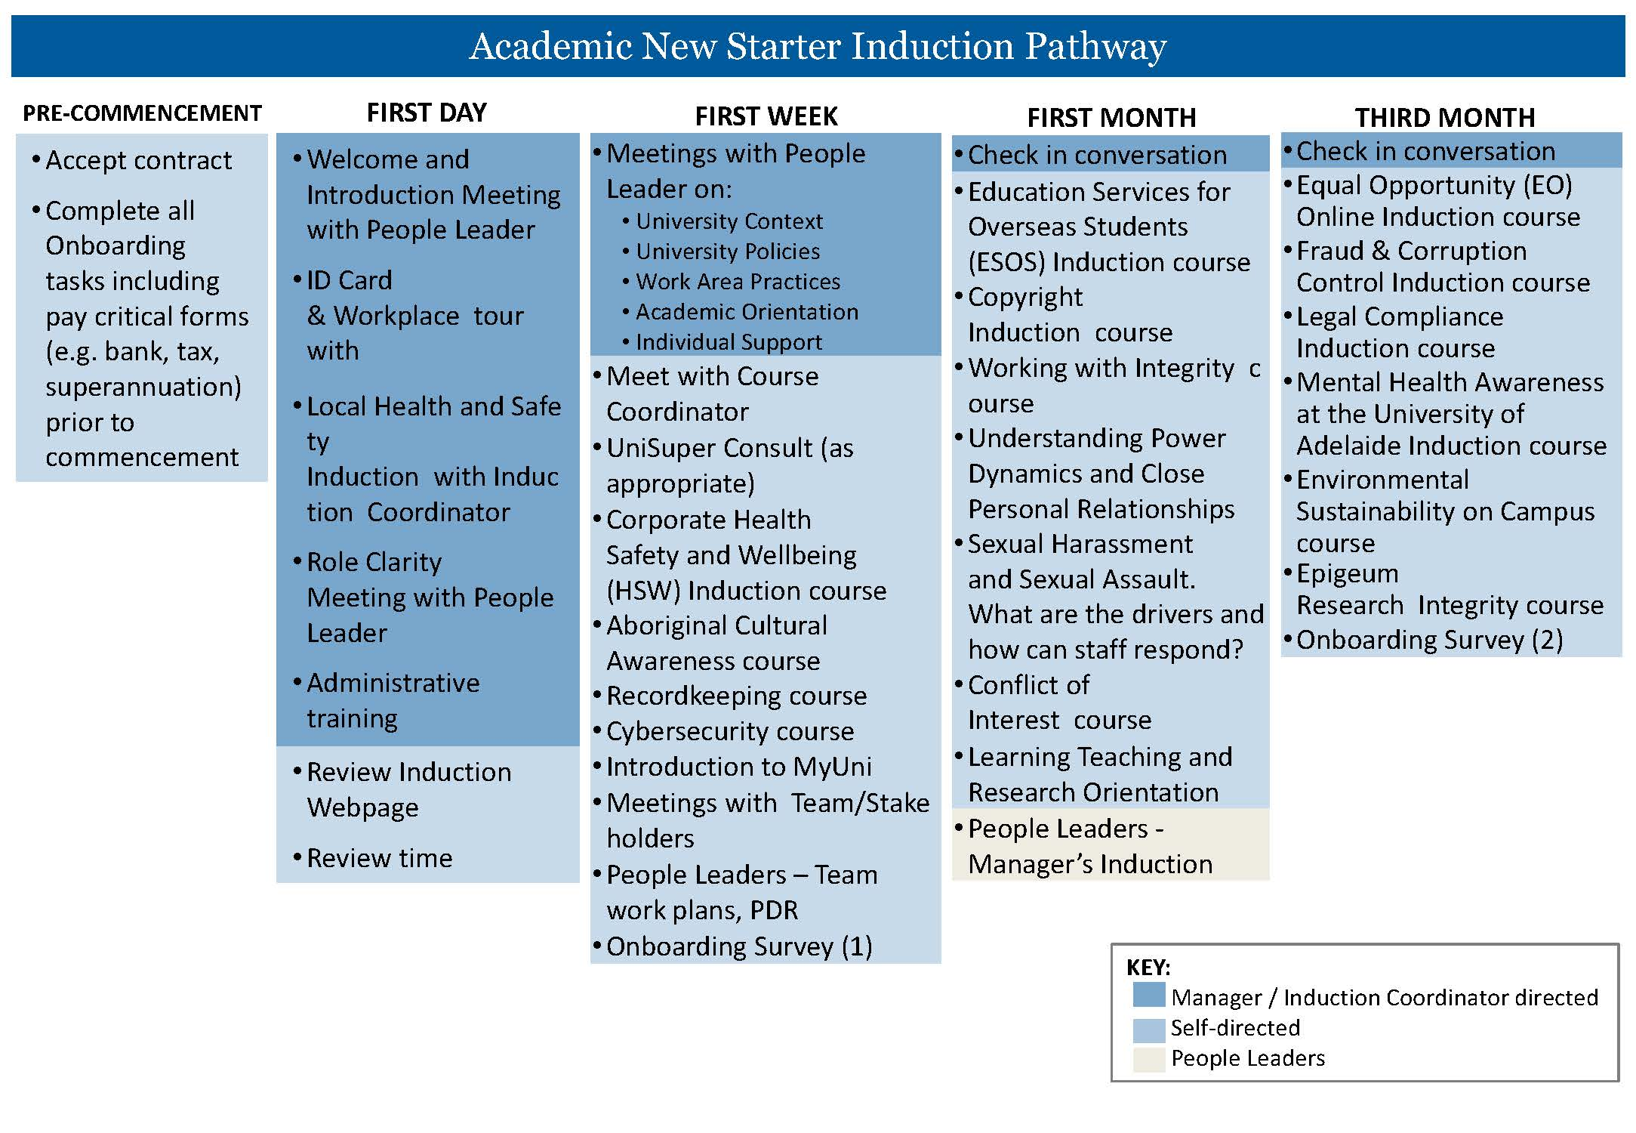

First Day
Time | Activity Description | Responsible | ü
^These meetings may be combined depending on the people leader’s preferences
XXX | Welcome and Introduction Meeting^– an opportunity to meet with your people leader and get oriented for your first day | <People Leader Name>
XXX | Settle in time – set up computer, can start on ‘administrative training’ below if time
XXX | Workplace tour – an opportunity to familiarise yourself with your local work area, including relevant facilities
XXX | Local Health and Safety Induction – more information about Health, Safety and Wellbeing | <People Leader Name>
XXX | Staff ID Card Pick Up – you will need to bring government-issued photo ID to collect your staff ID card  More information about Staff ID Cards  Campus map | <Induction Coordinator Name>
XXX | Role Clarity Meeting^ – an opportunity to understand broad expectations of your role and initial priorities. | <People Leader Name>
 | Lunch – Free Time
XXX | Administrative Set Up  This list will help you set up upon arrival. Your induction coordinator or leader can assist with local practices like using Teams, shared drives, or office equipment.  ​​☐​Outlook/Calendar (shared calendars, room bookings)  ☐Set up email signature  ​​☐​MS Teams (if applicable)  ​​☐​Shared network drive – update or request access here.  ​​☐​ Phone set up guide.  ☐Request voicemail set up via this form if required.  ​​☐​Request to be added to the Staff Directory via this form.  ​​☐​Overview of office equipment (e.g. printer/photocopier). Information about Follow You Printing  ☐Assess the ergonomic setup of your workstation (resources are available to assist).  ☐eProcurement (University purchasing system, if applicable)  ☐ Corporate Credit Cards application (if applicable)  ☐ Parking and Transport Options  ☐Local intranet  ☐Local Mail processes, if relevant (incoming, internal, external).  If you need any assistance with IT set up, you can contact IT support available via chat, phone (+61 8 8313 3000), service ticket, or self-service | <Induction Coordinator Name>
 | Review time  ☐Review the Induction website.  ☐Familiarise yourself with the required induction modules  ☐Familiarise yourself with the Academic Role statement and Individual Academic Profile  ​​☐​HR website – Staff Services Online (SSO), Professional Development Review (PDR), Health, Safety and Wellbeing (HSW).  ​​☐​Marketing website (document templates and tools).  ☐IT Website. There is also some information about the basic University IT systems and how to access them on the Induction website here.  ☐Staff Services website with quick links to a range of staff services | New Starter
First Week
Date/Time | Activity Description | Responsible |  | ü
XXX | Meeting/s with People Leader - opportunity to ask questions, troubleshoot issues, and clarify priorities. Common topics include university context, policies and procedures, and work area practices. | <People Leader Name>
 | Course Coordinator (if applicable)  Schedule a time to meet with the course coordinator for the courses you are teaching. | New Starter
 | UniSuper Consult (as appropriate)  UniSuper is the University’s nominated default fund and a complimentary UniSuper consultation is available to you. You can schedule a meeting with them online.  You can also check out this 6-minute video to understand UniSuper a little more. | New Starter
 | Induction Courses  Complete the relevant Induction courses in the first week. | New Starter
 | Team/Stakeholder meetings as required  - Attend meetings with team members and/or stakeholders as scheduled. | New Starter
 | <Stakeholder meetings>
 | <Meet with Associates Deans Learning & Teaching/Research if applicable>
 | <Meeting with Buddy, if applicable>
 | Onboarding Survey – Part 1  To help improve Recruitment and Induction processes, all staff new to the University of Adelaide are asked to participate in a short Onboarding Survey at 2 weeks and 3 months. You will receive an invitation via email. You are also welcome to submit feedback about your induction anytime via the Induction website or to the HR Organisational Performance team directly. | New Starter
 | Are you a People Leader?  - Meet with your team to discuss work plans and existing team priorities.  - Meet with Individual team members to discuss the objectives in their Professional Development Reviews (PDRs).  - There are a number of resources to support you in your role as a people manager at the University located on the Manager’s Induction webpage. For further information, please contact learninganddevelopment@adelaide.edu.au | New starter
First Month
Date/Time | Activity Description | Responsible |  | ü
 | Induction Courses  - Complete the Induction courses listed for the first month | New Starter
 | Learning, Teaching and Research Orientation  - Review Learning and Teaching webpage (including Resources for Educators) and Research webpage (including the Researchers Portal)  - The Learning Enhancement and Innovation team provides a range of services in partnership to enable your teaching activities and goals. These include learning design, innovative educational technologies, learning analytics, activity and resource design, and 24/7 MyUni support.  - If you will be supervising HDR students complete HDR Supervisor Induction and apply to join the Supervisor Register  - Staff new to the University are encouraged to participate in the ADEPT CPD Framework Developing Educators pathway.  - Familiarise yourself with the services and support available to students so that you are equipped to guide them. Information is available on the induction website.  - The University Library offers a range of services to support research and teaching. | New Starter
XXX | Check in Meeting  - Opportunity to connect with your People Leader to discuss your progress with induction, understanding of the School/Faculty/Division and the University, and raise any questions or issues.  - Discuss and schedule Planning, Development and Review process  - Discuss Probation process and, if applicable, schedule probation meetings. More information about the probation process can be found here. | People Leader
Third Month
Date / Time | Activity Description |  | Responsible |  | ü
 | Induction Courses and other Relevant Learning  - Complete the Induction courses listed for the third month |  | New Starter
 | Course Progress (teaching staff)  Schedule time with your Line Manager to reflect and review on the progress of the course/s you are teaching. |  | New Starter
 | Onboarding Survey – Part 2  You will receive an invitation to participate in the 3-month onboarding survey via email. |  | New Starter

Congratulations!
At the end of 3 months, you have come a long way in getting to know your role, team, and the organisation. While induction initiatives are typically targeted in the first 3-months, learning is at the heart of everything we do and we anticipate your learning will continue. Don’t hesitate to come back to the induction website, courses, and, most importantly, the support networks you’ve built through your induction process, as you continue in your role.

