New Starter Details
Name:
Position: | xxx
School/Branch: |  | xxx | Commencement Date: | xxx
People Leader: |  | xxx | Induction Coordinator*: | xxx

Welcome to The University of Adelaide! This Induction Agenda has been personalised for you to support your transition into your role. It includes an overview of what to expect for your induction and activities you may need to complete. Additional information and resources are available on the Induction website.
As casual employment can be varied, the Supervisor and/or Induction Coordinator will need to use their discretion to ensure the induction is relevant and appropriate for the staff member. <REMOVE THIS BEFORE FINALISING>
Pathway:
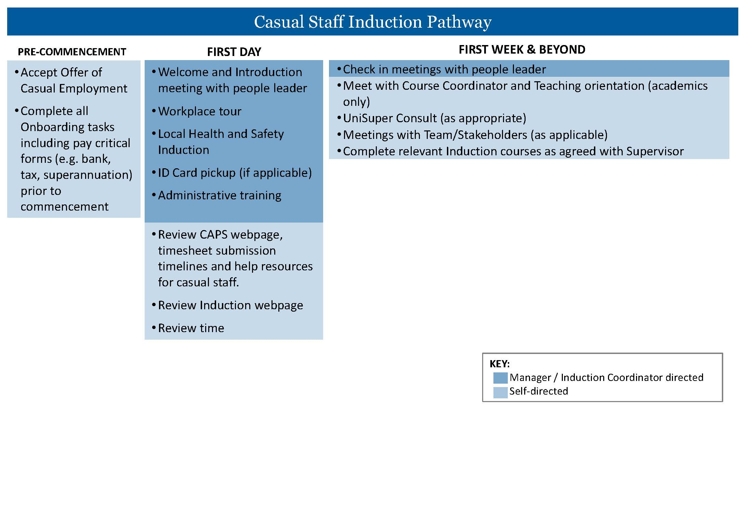

First Day
Time | Activity Description | Responsible | ü
^These meetings may be combined depending on the people leader’s preferences
XXX | Welcome and Introduction Meeting^ - an opportunity to meet with your people leader and get oriented for your first day | <People Leader>
XXX | Settle in time – set up computer, can start on ‘administrative training’ below if time | New Starter
XXX | Workplace Tour - an opportunity to familiarise yourself with your local work area, including relevant facilities | <Induction Coordinator>
 | Local Health and Safety Induction - more information about Health, Safety and Wellbeing | <People Leader>
 | Staff ID Card Pick Up – you will need to bring photo ID to collect your staff ID card  More information about Staff ID Cards  Campus map | <Induction Coordinator>
XXX | Role Clarity Meeting^ - an opportunity to understand broad expectations of your role and initial priorities. | <People Leader>
 | Lunch – Free Time
XXX | Administrative Set Up  This list will help you set up upon arrival. Your induction coordinator or leader can assist with local practices like using Teams, shared drives, or office equipment.  ☐ ☐Set up Multi-Factor Authentication (MFA).  ☐Passwords are able to be set-up through Manage your Account  ​​☐​Outlook/Calendar (shared calendars, room bookings)  ☐Set up email signature  ​​☐​MS Teams (if applicable)  ​​☐​Shared network drive (if applicable)  ​​☐​Phone set up guide.  ☐Request voicemail set up via this form if required.  ​​☐​Request to be added to the Staff Directory via this form.  ​​☐​Overview of office equipment (e.g. printer/photocopier). Information about Follow You Printing  ☐Assess the ergonomic setup of your workstation (resources are available to assist).  ☐Local intranet.  ☐Local Mail processes, if relevant (incoming, internal, external).  IT Support is available via chat, phone (+61 8 8313 3000), service ticket, or self-service | <Induction Coordinator>
 | Review time  ☐Familiarise yourself with the CAPS webpage and Timesheet Submission and Validation Deadlines. Help resources on timesheet submission are also available.  ☐Review the Induction website.  ​​☐​Marketing website (document templates and tools).  ☐IT Website. There is also some information about the basic University IT systems and how to access them on the Induction website here.  ☐Staff Services website with quick links to a range of staff services | New Starter

First Week & Beyond
Date / Time | Activity Description | Responsible | ü
XXX | Meeting/s with People Leader – opportunity to ask questions, troubleshoot issues, and clarify priorities. Common topics include university context, policies and procedures, and work area practices. | <People Leader>
 | Teaching Orientation  - If your Supervisor is not your course coordinator, you will need to schedule a time to meet with your course coordinator to clarify anything and be pointed in the right direction for support.  - It may be a good idea to contact Learning Enhancement & Innovation (LEI) relating to MyUni (Introduction to MyUni Course).  - The Learning and Teaching webpage outlines information for new teaching staff.  - Familiarise yourself with the services and support available to students so that you are equipped to guide them. | New Starter
 | UniSuper Consult (as appropriate)  UniSuper is the University’s nominated default fund and a complimentary UniSuper consultation is available to you. You can schedule a meeting online.  You can also check out this 6-minute video to understand UniSuper a little more. | New Starter
 | Induction Courses and other relevant learning  Complete the following Induction courses:  <Review this list and remove courses where necessary. Casual staff members will need to self-enrol for the courses using MyLearning (Ethics and Integrity modules) and MyUni (for other courses)>  ☐Corporate HSW Induction (highly recommended for all staff)  ☐Aboriginal and Cultural Awareness Induction course  ☒Recordkeeping induction course  ☐Cybersecurity induction course  ☐Introduction to MyUni (Canvas)  ☐ESOS Induction course  ☐Copyright induction course - only required for  Academic staff Level B and above, Level A academics in a teaching role and professional staff in a role that requires an understanding of copyright.  ☐Working with integrity  ☐Understanding power dynamics and close personal relationships  ☐Sexual Harassment and Sexual assault – what are the drivers and how can staff respond?  ☐Conflict of interest  ☐Epigeum Research Integrity course – recommended for Academics and Professional Staff associated with research. | New Starter
 | Team / stakeholder meetings as required  - Attend meetings with team members and/or stakeholders as scheduled. | New Starter
 | <Stakeholder meeting>
 | <Stakeholder meeting>

