QUICK GUIDE TO COMPILING RESEARCH APPLICATIONS FOR CONSIDERATION BY THE UNIVERSITY OF ADELAIDE ANIMAL ETHICS COMMITTEE

Drs Adam O’Connell and John Finnie
University Veterinarians

The purpose of this guide is to acquaint researchers with the style of answers that the AEC requires to questions posed by RM6 and thus help them to compile an application that is more likely to be favourably considered, and more rapidly approved, by the AEC.
Language and style:
The most important thing to remember, when writing the application, is that the AEC is comprised of members of the public (lay members), as well as those with associations to the University. The background of the individuals in the AEC varies enormously, with many members having no scientific training or experience. It is important that all members, including lay members, can easily read, understand and assess an application. If any member finds an application difficult to read or understand, resubmission may be requested.
Lay language means minimising scientific jargon where possible, using plain language where possible and avoiding excessive numbers or acronyms. While it may not always be possible to avoid using scientific terminology, where it is used a plain English definition / explanation should be provided when it is first used. Acronyms that are fundamental to an application are okay, but should be defined in full the first time they are used.
The animal ethics application is not a peer-reviewed scientific review or grant funding application. Do not copy and paste from grant funding applications. While you have to convince the AEC of the scientific merit, avoid using large numbers of references in text or detailed explanations of laboratory techniques not relevant to the application. Clear, concise, well-structured answers that give a broad understanding to all members of the AEC are more important than detailed scientific answers that only a fellow scientist would understand.
Length:
Length does not matter and a long application should not be interpreted as a good application. A short application with clear explanations is much better than a long, confusing application. While it is good writing technique to try and keep an answer as short as possible, the application should be as long as is necessary to clearly and simply answer the questions.
Experience and training requirements:
It is important to demonstrate that investigators are either competent and experienced in proposed procedures or will be given adequate training, support and supervision to become competent.
Please make it clear what the experience or training requirements are for all the investigators. The application must clearly detail which investigators are competent to perform the proposed procedures, why they are competent, which investigators need training, how they will be trained, who will provide the training and why they are competent to train.
If additional animals are needed for training, these animals must be included in the application. This is not required if LAS or UV’s are training investigators using LAS animals.
Project title:
Should succinctly explain the principal aim of the project and what aspect of a given disease the proposed research is attempting to understand and/or improve (e.g. pathogenesis, therapy).
Short lay summary:
It is very important that this project summary is written in lay language so it is intelligible to lay members of the AEC. It should succinctly explain what the project hopes to achieve and, if successful, what the significance of these positive research results will be to improving an understanding of this particular disease.
Keep in mind that this summary is what will be provided by the University to an external organisation (e.g. newspaper) seeking to understand what this research is all about.
Scientific justification:
This section provides the researcher with an opportunity to explain to the reader what the project aims to achieve and how it will hopefully lead to a better understanding of disease development mechanisms/treatment modalities. A good answer to this question will help the reader understand why the use of animals is justified in achieving these aims. Again, it is very important to write this section in lay (non-scientific) language.
Animal number justification:
A good answer here will provide the reasoning behind how animal numbers were derived and how the size of experimental cohorts was arrived at. This section is closely scrutinised and frequently debated by the AEC.
The AEC will generally require a power calculation to justify the number of animals sought (or explain why this cannot be performed) and researchers are encouraged to consult (and cite) a biostatistician, unless they are very experienced with statistical methods.
Typically, members of the AEC will look for consistency of numbers throughout an application and compare numbers here with those provided in sections 5.1 Animals required, 6.1 Procedure description, any attached flowchart / experimental plan etc. It is really important, before submitting an application to review the numbers in various sections and ensure they are all consistent.
Ensure you consider additional animals for potential / likely problems and training as necessary. If you ask for the absolute minimum animals based on a power calculation, and one becomes unwell or dies, then your study will be underpowered.
The 3 R’S (replacement, reduction, refinement):
The 3 R’s are now a major focus of improving animal welfare standards and, accordingly, your answers to these questions should be carefully considered and well argued.
- Replacement:
There will be many projects for which an animal model is clearly required. However, you should explain why an in vivo system is obligatory to achieve the aims of your research and why other alternatives (e.g. in vitro) are unsuitable.
- Reduction:
In addition to showing that the minimum number of animals will be used (and justify this with a statistical power calculation) to achieve the aims of this research, you are encouraged to consider using surplus animals from this (and other) universities/research institutions and making any unused animals from your project available to other researchers.
Gender is becoming an issue in scientific research and you should explain why only one sex is being used (if this is the case). There may be instances in which proof-of-principle is initially desired to be demonstrated in one sex and, if proved, will then be extended to the opposite sex, but this should be carefully explained.
- Refinement:
This is arguably the most scrutinised of the 3R’s by the AEC and your answer should reflect a well-considered inclusion of improvements to the experimental paradigm from the animal’s perspective. For example, what will be done to alleviate/minimise pain/distress (analgesia, anaesthesia, sedation), what training will investigators undergo and what is their experience, what environmental enrichment (e.g. toys) will be provided to create better conditions for the animals and allow normal behaviours to be performed, and how will you make it easier for animals to eat and maintain body weight (e.g. soaked food)?
A carefully constructed CRS will be an important element of the “Refinement” process and it should be specific to the project under consideration (see later comments on CRS).
If the experimental procedure is invasive and/or painful, the level of pain/distress induced should be quantified and justified in terms of the importance/relevance of the expected experimental outcomes.
Animals required:
Very important: Ensure that the total number of animals requested here matches the animal numbers stated in other parts of the application. Where suitable, request additional animals to cover for animals that become unwell or die unexpectedly, so that studies do not become underpowered.
Animal housing:
Please check with the facility manager, in advance, that there will be accommodation available when you need it. Also, if assistance is required for animal monitoring, this should be arranged in advance and agreement stated in the application.
Animal fate:
Be consistent with any method of humane killing throughout the application. Use correct terminology.
Procedure description:
- You should state precisely what procedures the animals will be subjected to and their temporal sequence. This should be in language intelligible to lay members of the AEC (scientific terms, unless in common usage, should be explained in lay terms).
- State what drugs/other agents will be administered and their dose rate/frequency and route of administration.
- State which tissues will be collected and, if blood is to be collected, the volume and frequency of its collection.
- Where applicable, state how many people will be assisting with procedures (e.g. for anaesthesia, typically two people are present, one to perform the procedure and one to assist and monitor the animals. This needs to be clearly stated).
- Give a brief explanation of how outcomes will be evaluated / results will be analysed and precisely what techniques will be used to evaluate the results.
- There will be separate sections for teaching applications or wildlife projects etc. which will drill into the details around staff to student numbers, maximum time of restraint, maximum number of students per animal, environmental conditions etc. It doesn’t hurt, where applicable, to reinforce those details in procedure description or any other relevant section to ensure the AEC appreciate the point.
Ensure you discuss any transportation, acclimatisation, humane killing etc. Please include references to relevant SOP’s in the procedure description, such that is understood you are aware of relevant SOP’s and will refer to them. Common lab animal SOP’s are available on the Laboratory Animal Services (LAS) website under ‘Information for staff and clients > Policies and procedures’ while there are also common Roseworthy SOP’s available via staff members.
Either in this section, or another relevant section, common health issues for the colony or species and likely adverse events should be recorded. For example a breeding colony is likely to have sporadic birthing issues, still born animals and congenital abnormalities in offspring. Other examples include cancer in certain mice strains, occasional lameness in livestock etc.
For higher impact studies and studies which include anaesthesia, unexpected death or illness may occur (for example death during anaesthesia). An appropriate ‘expected’ percentage should be included here. Ensure additional animals are requested as appropriate.
Animal monitoring:
The frequency of monitoring should be clearly stated, and justified, together with the persons who will perform the monitoring and their experience.
A CRS will form a critical part of the monitoring process and it should be specific to the project under consideration (if a generic CRS is used, this should be justified). The CRS should:
- List 2 contact persons and their contact phone numbers
- List all the clinical parameters likely be expressed by animals in this project (including dyspnoea if tumour metastasis is anticipated)
- Starting weight and weight loss columns should be included and the time at which they were taken recorded
- Assign a score to all of the clinical parameters listed
- Show cut-off scores when action (e.g. seek veterinary advice, euthanasia) is required
- For tumour studies, any assessment of weight loss due to tumour-induced cachexia should take account of any counterbalancing increase in body weight to due enlargement of the tumour mass. As a guide, a tumour volume of 1000 mm³ is equivalent to ~ I gram of normal body tissue.
Substances administered:
You should include all drugs/other agents/cell lines to be administered to animals, together with their dose rate, and frequency and route of administration.
Transport of animals:
Please remember to include the relevant transport SOP in your application.
Training:
The CI is ultimately responsible for ensuring all investigators are competent, or that there is a training plan developed to ensure they will become competent. The application must clearly establish who is competent to perform procedures and why they are competent, who needs training, how they will be trained and assessed competent, by whom and the competency of the trainer.
Funding:
Please include the name of the funding body and the application number.
In addition to evaluation of a research project on animal welfare grounds, external, peer-reviewed funding is an important part of the AEC assessment of the scientific validity of the proposed study.
Attached documents:
These must be in PDF form.
- A flowchart or experimental plan complements the application, especially the procedure description, and is very useful to the AEC. It does not need to be flashy / can be very plain. It will be closely examined. A good flowchart can make a big difference in the AEC’s understanding and subsequently how they view an application. It is very worthwhile investing time in developing a good flow diagram. A good flowchart is often constructed in Microsoft Powerpoint and allows a quick and easy understanding of the overall experimental design, including a timeline of when procedures will be performed and the number of animals required at each time-point. It is essential if there are multiple aims/arms of the project. A good flowchart will enable the reader to more readily appreciate the overall aims and conduct of the research, with the allocation of animal numbers to each phase of the project being clearly shown. A very basic example is below (example only, you can present your flowchart however you would like to / however suits the project). Text explanations can accompany, the key feature is to make it easy to understand what is happening in the planned experiment.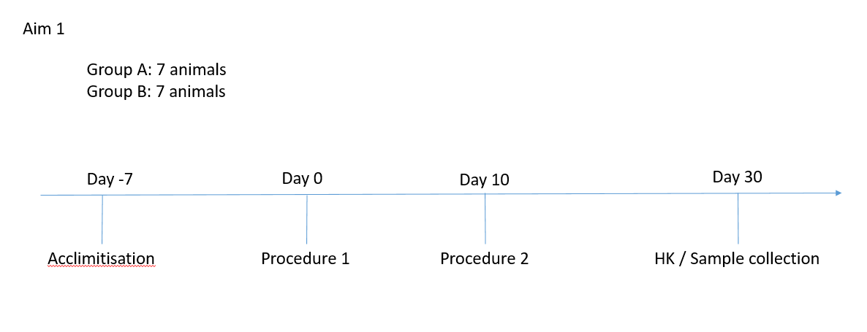
- Sometimes a detailed experimental plan is attached that may have been prepared for a funding application or publication. This is okay and can be useful for those members who would like to dig into things a little more, but it is not essential.
- SOP’s / Description of procedures: Typically the AEC like to see SOP’s or documents attached that explain major procedures or demonstrate they are standard techniques in the field. Any bespoke SOP’s need to be attached and should be referenced in Procedure Description. Please make sure any SOP is up-to-date and relevant.
- Pictures / diagrams of equipment or facilities are always encouraged and in certain circumstances will be requested if not attached – the classic a picture is worth a thousand words. e.g. picture of a bird with a tracking device attached.

