Framework for Decolonising Practice in Aboriginal Primary Health Care

The framework for decolonising practice below was developed by the research team in collaboration with the partner services. It aims to capture how Country, culture, and community sit at the heart of decolonising practice.
The inner ring illustrates the vicious cycle of ongoing colonisation that leads to power inequities, a discriminatory health system, and poor health outcomes, and loss of power and control for Aboriginal and Torres Strait Islander practice.
The outer ring documents the reinforcing cycle of decolonising practice strategies that primary health care services can use to counter these negative effects, strengthen connection to Country, culture, and community, pushback against ongoing colonisation, and pursue self-determination and sovereign resistance.
These strategies are further explored in the project report, with examples from each of the partner services. The report is available at: https://www.adelaide.edu.au/stretton/our-research/stretton-health-equity/decolonising-practice-in-aboriginal-and-torres-strait-islander
A short film introducing decolonising practice is also available to view at: https://vimeo.com/1035024292/44d0a7297d
The editable text boxes have been included to allow primary health care services to tailor the framework to their local context, and highlight ways in which their service is operationalising these principles of decolonising practice on the ground for their community.

DECOLONISING PRACTICE FRAMEWORK
How we enact decolonising practice at: [Insert Service name here]
At our service, this looks like…

At our service, this looks like…

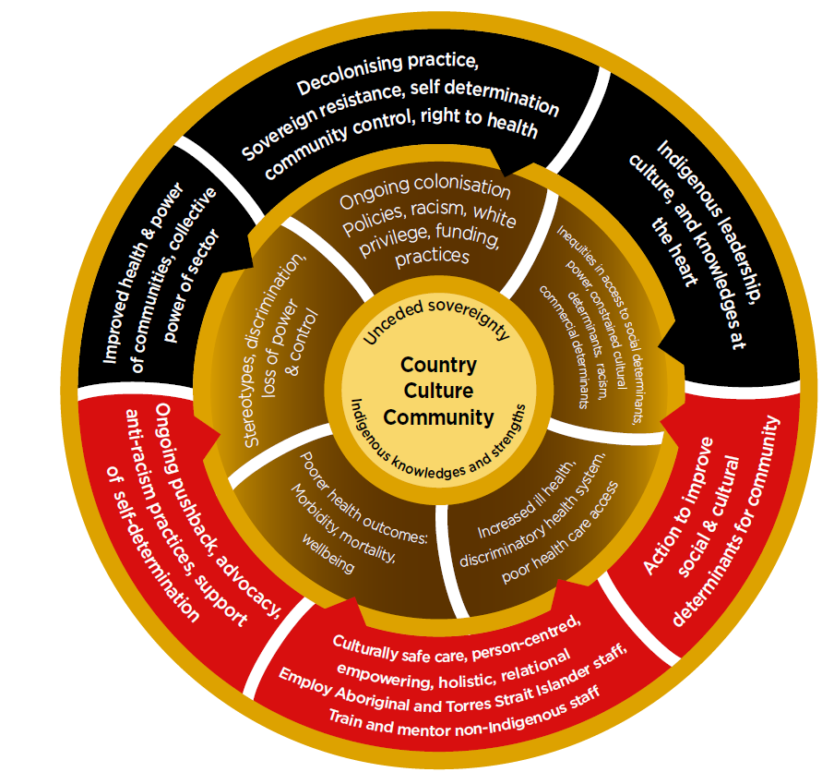
Place Service logo here
At our service, this looks like…

At our service, this looks like…

At our service, this looks like…

At our service, this looks like…

